Names: _____________________________________________________________________

Names: _____________________________________________________________________

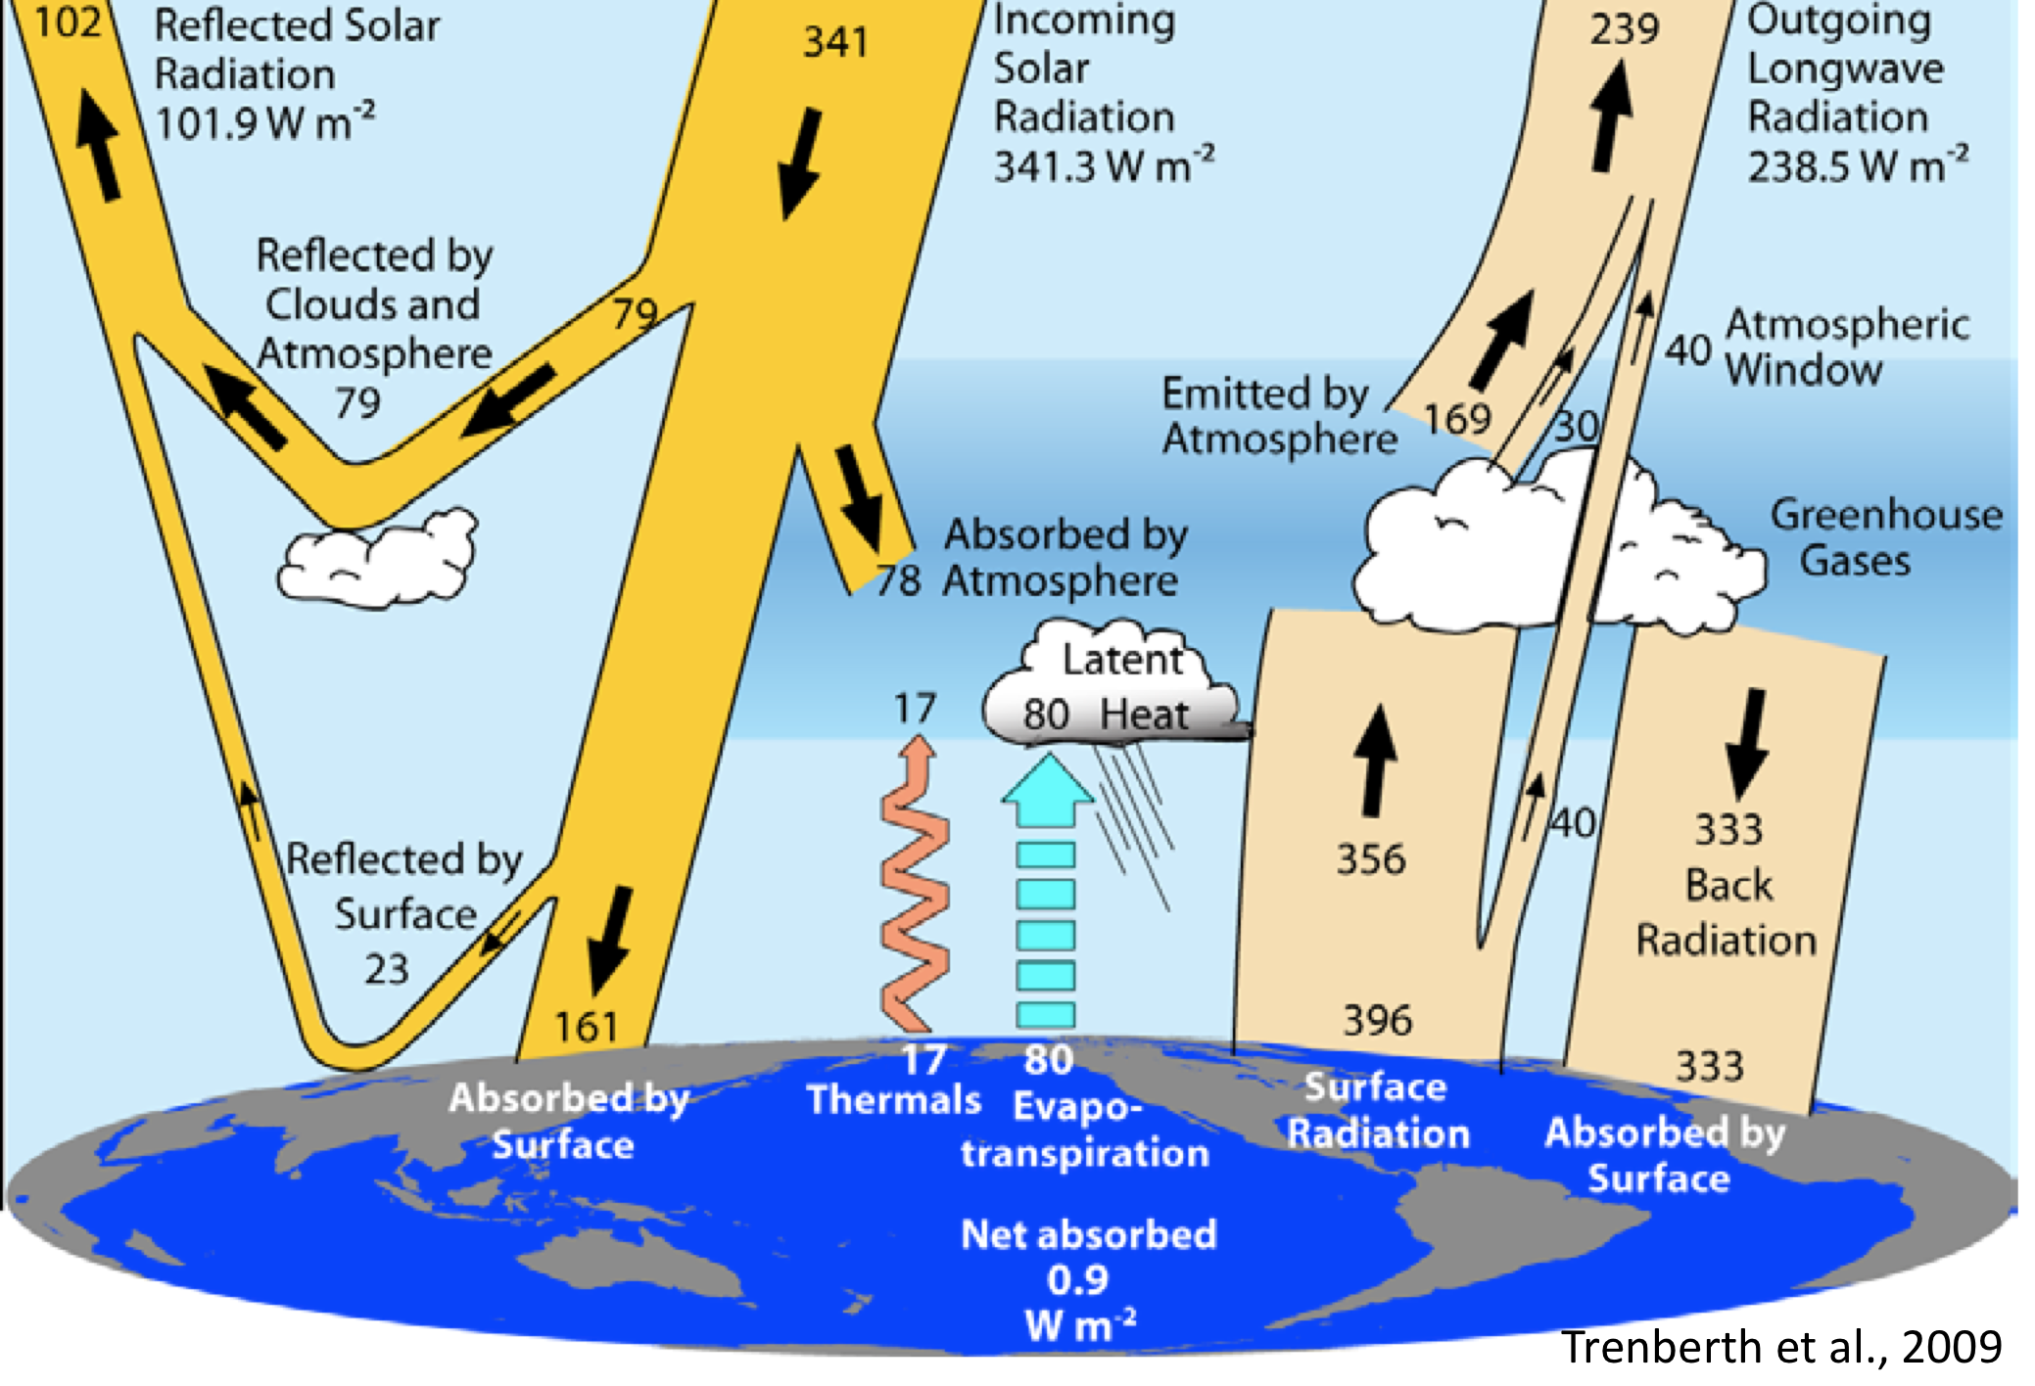

**1**

**2**

**3**

**184**

238

168

*modified*

**Earth’s Radiation Balance**

This diagram is a schematic highlighting the most important energy fluxes in the Earth’s climate system. We will see this worksheet many times over the course of the class. The black dotted lines artificially separate the system into three distinct layers. Use this diagram to answer the following questions.

1. What are the energy fluxes (including signs) entering the entire climate system from space (i.e. if you treat all three layers as one)? Identify the source(s) of these fluxes.
2. What are the fluxes leaving the system? Do these balance the incident energy fluxes? Do you expect that the two should or should not be in balance? Explain.
3. Consider the “central” atmosphere, represented by layer 2. Identify all fluxes entering this layer, and all fluxes leaving this layer. Are incoming and outgoing fluxes in balance? Do you expect that the two should or should not be in balance? Explain.
4. Now consider layer 3 representing the earth’s surface. Again, identify all incoming and outgoing fluxes and determine if they are in balance.
5. For the surface imbalance you found, how much would the surface temperature have to increase to restore balance? *Hint: recall that dE/dt = Iup+ Idnand treat the earth’s surface as a blackbody. Also recall the Stefan-Boltzman equation.*